**Automated Model Selection and Hyper parameter Optimization Using Bayesian Optimization Design**

Block Diagram:

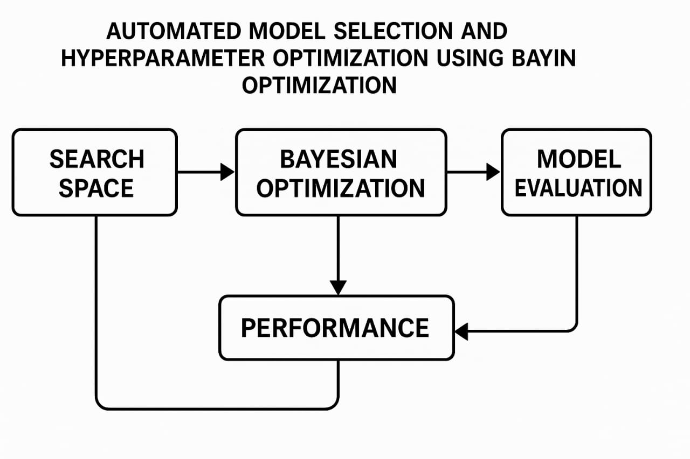

**Search Space**

* This defines the range of **models** and their **hyper parameters** to explore.
* It includes:
  + Types of models (e.g., SVM, Random Forest, XGBoost)
  + Hyper parameters (e.g., learning rate, max depth, kernel type)
  + Categorical, discrete, or continuous values
* This is the foundation that the Bayesian optimizer explores.

**🔷 2. Bayesian Optimization**

* This is the core **optimization engine**.
* It uses a **surrogate model** (like Gaussian Process or TPE) to predict performance and guide the search.
* Based on past performance, it selects the **next best configuration** to try using an acquisition function (e.g., Expected Improvement).

**🔷 3. Model Evaluation**

* The suggested configuration (model + hyper parameters) is trained and evaluated.
* Evaluation is done using validation data or cross-validation.
* The **objective metric** (e.g., accuracy, F1-score, MSE) is computed to assess performance.

**🔷 4. Performance**

* The performance results are **fed back** into the Bayesian optimizer.
* This helps the surrogate model **update its understanding** of the search space.
* Better future suggestions are made based on this updated performance data.

**🔁 Feedback Loop**

* The **loop continues**: Bayesian Optimization → Model Evaluation → Performance → Update.
* This iterative loop improves the chances of finding the **optimal model + hyper parameter combination**.

**Summary of Flow**

Search Space → Bayesian Optimization → Model Evaluation → Performanc

↑ ↓

└───────────── Feedback Loop ───────────────┘